**Requirements Specification**

Group Name: F

Group Members

Grigor Danut x16114515

Ruben Campean x16120043

Antonio Penna x01417383

Umar Rafique x18142061

Contents

Overview 2

Product Overview 2

Use Case Design 2

**Exceptional flow** 4

**Termination (outcome)** 4

***Activation*** 4

***Main flow*** 4

***Post condition*** 6

***Activation*** 7

***Main flow*** 7

***Alternative flow*** 7

***Exceptional flow*** 8

***Post condition*** 8

Technical Specification 10

Gantt Chart 13

Wireframes 14

Deployment Strategy 22

# Overview

This Document will have a look at the product that will be developed and go in detail on the technical requirements, providing wireframes of how the Application will look, how the group will develop the Application and where the Application will be deployed.

# Product Overview

The product is an Android Application which will be deployed on the Android Play Store. The goal of the application is to aid paramedics when they arrive to a crash site or to a house following up on an emergency response call. The application can allow the user to scan their fingerprint and allow them to access medical history details. There will be three different views, The Doctor view will allow him/her to access all of the medical history of all his patients and also make changes according to appointments of changes in condition. The paramedic can search the user by fingerprint and the application will give access of the patient's profile showing the medical history of the patient, Paramedics have access only to view profiles not edit them. The patient can access their profile either through password or by fingerprint, The Patient only has access to view his profile, he can’t make changes or view other patients profile.

# Use Case Design

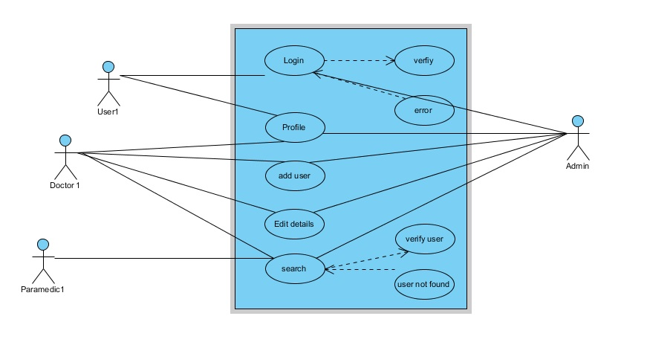

Use case 1: Login

***Scope***

The scope of this use case is to identify all the users in the System.

***Description***

This use case redirects the user traffic to different panel, with different access.

***Flow Description***

*Precondition*

1. The user has internet connection.
2. The user has to be register to the system
3. The user is authenticated.

***Activation***

1. This use case starts when a user login in.

***Main flow***

1. System display login screen.
2. The user intent to login.
3. The system request password or fingerprint.
4. The user gives their details.
5. The system checks user details.
6. The system verifies the user detail and redirect the user to their panel.

***Alternative flow***

1. The system indicates that user and passwords were incorrect.
2. System request user to retype username or password [A1 retype credential] or exit. [A2 Exit]

[A1 retype credential]

* 1. Continue in main flow point 3.

[A2 Exit]

* 1. Customer Exit

System terminate use case

## **Exceptional flow**

1. The system suspends the account after five failed attempts.
2. The user is informed by an email that the account is suspended and user is invited to contact Customer Service.
3. The use case fail.

## **Termination (outcome)**

* 1. The user access to his details.

***Post condition***

* 1. The system goes into a wait state

Use case 2: Profile

***Scope***

The scope of this use case is to give all users their medical history.

***Description***

This use case shows the user their profile and their access to system.

***Flow Description***

***Precondition***

* The user has internet connection.
* The user must be register to the system
* The user is authenticated.

## ***Activation***

This use case starts when a user login in and get verified by system.

## ***Main flow***

1. System display Profile screen.
2. The user can check their details.

***Alternative flow***

1. There is no alternative flow as profile comes after verification and user cannot do a lot because it read only.

***Exceptional flow***

---

***Termination***

The user access to his details.

***Post condition***

The system goes into a wait state

***Use case 3: Add User***

***Scope***

The scope of this use case is to access to doctors, so they can add the user on spot.

***Description***

This use case shows the option to add a user to verified doctors, so they can add the users to the system.

***Flow Description***

***Precondition***

1. The doctor has internet connection.
2. The doctor must be register to the system
3. The doctor is authenticated.

***Activation***

1. This use case starts when a doctor login in and get verified by system. On doctor profile this use case give an option to add user.

***Main flow***

1. System display Profile screen.
2. The doctor has an option to add user once clicked.
3. The system request for user details.
4. The doctor type in the name.
5. The system request for figure print and photo of the user.
6. The doctor provides it.
7. The system request for username for the user.
8. The user can decide the username / password and an email.
9. The System check the doctor details, verify it and add the user to the system in list with the doctor.

***Alternative flow***

1. System request Doctor to confirm the user details [A1 Confirm] or edit. [A2 Edit]

[A1 Confirm]

1. The System issue the confirmation message the user is added.

[A2 Edit]

1. Continue in main flow point 3.

***Exceptional flow***

---

***Termination***

The user and doctor can access to details.

## ***Post condition***

The system goes into a wait state.

**Use case 4: Edit User**

***Scope***

The scope of this use case is to give access to doctor, so they can edit details on user profiles.

***Description***

This use case shows the option to edit details of users to verified doctors, so they can edit details of users and add additional notes on user profiles.

***Flow Description***

***Precondition***

1. The doctor has internet connection.
2. The doctor must be register to the system
3. The doctor is authenticated.

## ***Activation***

This use case starts when a doctor login in and get verified by system. On doctor profile this use case give an option as details.

## ***Main flow***

1. System display Profile screen.
2. The doctor has an option to edit user once clicked.
3. The system request for user details.
4. The doctor type in the username.
5. The system request for figure print and of the user.
6. The doctor provides it.
7. The system gives an option to doctor to edit details on that user.
8. The System check the doctor details, verify it and edit the user details in to the system.

## ***Alternative flow***

1. System request Doctor to confirm the user details [A1 Confirm] or Cancel. [A2 Cancel]

[A1 Confirm]

1. The System issue the confirmation message the user detail is added by doctor name.

[A2 Cancel]

1. Continue in main flow point 1.

## ***Exceptional flow***

---

***Termination***

The doctor goes back to his profile.

## ***Post condition***

The system goes into a wait state

***Use case 5: Search Patient***

***Scope***

The scope of this use case is to search Patient in the System.

***Description***

This use case redirects the user traffic to different panel, with different access.

***Flow Description***

***Precondition***

1. The Paramedic and Doctors have access to internet.
2. The Paramedic, Doctors and patients has to be register to the system.
3. The Paramedic or Doctors is authenticated.

***Activation***

This use case starts when a user login in.

***Main flow***

1. The Paramedic or Doctors intent to search patient credential.
2. System display searching field.
3. The system request Patient details or fingerprint.
4. The Paramedic or Doctors gives patient details.
5. The system verifies Paramedic or Doctors details.
6. The system displays the patient details.

***Alternative flow***

1. The system indicates that user was not found.
2. System request to retype patient details [A1 retype credential] or exit. [A2 Exit]

[A1 retype credential]

3. Continue in main flow point 3.

[A2 Exit]

4. Customer Exit

System terminate use case

***Exceptional flow***

-----

***Termination***

The patient’s details are displayed.

***Post condition***

The system goes into a wait state.

# Technical Specification

The requirements of the project should be mapped against suitable technologies. Each group is required to build their solution using Bootstrap, Java and MySQL, however addition libraries and APIs should be identified in this section to demonstrate a technical understanding of how the group will complete the project.

**Hardware**

As the software being developed will need either a fingerprint scanner or an NCF Reader as user interface, it will be developed for Android OS starting from Android Marshmallow. Mobile phone capable of having a fingerprint scanner or NCF scanner. To scan the fingerprint in order to Login the users can use the feature available on the android smart phones. Mobile phones with integrated fingerprint scanners first appeared on the market in 2015 with the release of Android Marshmallow 6.0. (Official Android Blog, 2015)

**Fingerprint Scanner**

One of main technologies around which the project revolves is a fingerprint scanner that is integrated into its user’s a mobile phone. The fingerprint scanner is used to access medical information of its user, that may be of help to paramedics treating the user in case of an emergency. To scan and record the fingerprint of their patients the doctors can also use the biometric fingerprint scanner which can be connected to a smartphone or another computer device (laptop, desktop). The input from the fingerprint scanner will be encrypted and protected by a password. The fingerprint password also called crypto key will be stored by Android keyStore, apart from the normal passwords. Android keyStore uses a KeyChain API library. Android keystone will encrypt the key in a specially protected place that will prevent unauthorized access. Key generator use API library, it is used to implement the crypto key. (ProAndroidDev, 2017)

One of the benefits that this new software will bring, is that the fingerprint scanner on any of the parties involved smartphone will suffice for the purpose of accessing the required stored information.

**Database**

For the purpose of this project a Database that’s allow users to store their credential will be used. The team opted for a real time (Google Firebase) database, capable to share and record data live. The team will develop a working database structure, that is able to record and retrieve data, with the use of fingerprint.

**• Near-field communication (NFC) Reader**

Near-field communication (NFC) are communication protocols that make it possible for data to be shared between two adjacent electronic devices. The two devices are usually brought within 4 cm (1.6 in) of each other. (Faulkner, 2015)

For the purpose of the solution being developed, this technology is the alternative to a fingerprint scanner. In other words, where the fingerprint scanner is not available for secure and reliable access to medical data of a user, that data may be retrieved via the paramedic and the patient.

**Software:**  **Android Studio**

Android Studio will be used to develop the application. One of this choice of OS is that it is most widely used and therefore using this will enable the largest possible number of users of our application. “In the second quarter of 2018, 88 percent of all smartphones sold to end users were phones with the Android operating system” (Statista, 2018)

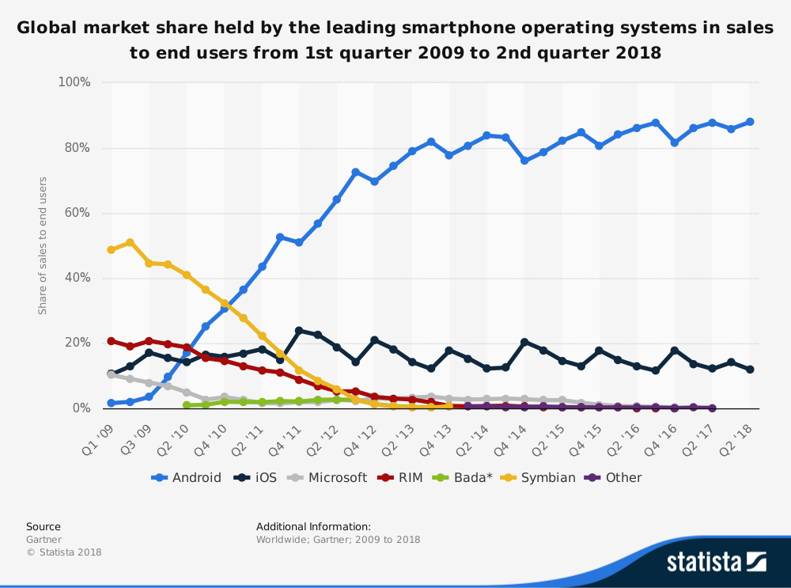

For the development of the application the team will use AIP6, as this accommodates Android Marshmallow, which is the version of Android that fully support fingerprint scanner. (Android Developers, 2018)

Considerations is also given to Android 4 (KitKat) that does not have a native support to fingerprint scanner, the team intend to build a second option that use NFC, able to tap and receive information about the patient

To enable the permission in Android, the team need to add the following code in the Manifest

“<uses-permission android:name="android.permission.USE_FINGERPRINT" />”

(Android Developers, 2018)

**Xml**

Android has Xml to stylish the application, the team will use “Affinity design” software in order to develop and use customized images and “skins” to. To make the app responsive the team will reference trough this website:

(Android Developers Blog, 2011)

**Inheritance**

Object oriented principles will be used when the code will be scripted for the solution and a super classes.

**Knowledge as resource**

Android and Firebase are the software development tools that will be used for the build of the solution. This was one of the first requirements in terms of team knowledge that was considered as the team was assembled. As there will be the NFC and Fingerprint Scanner integration software that will also be required for the running of the software, these applications are additionally accounted for under software requirements in this paper.

# Gantt Chart

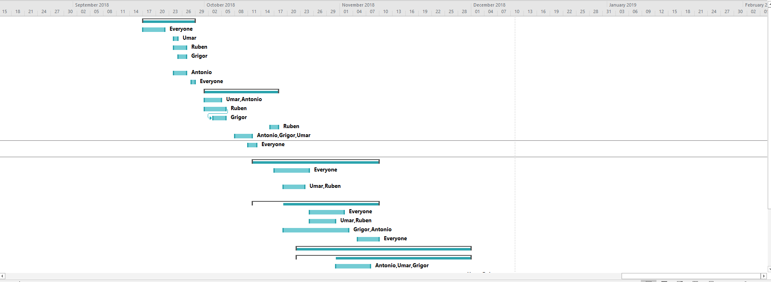

Description of Gant chart

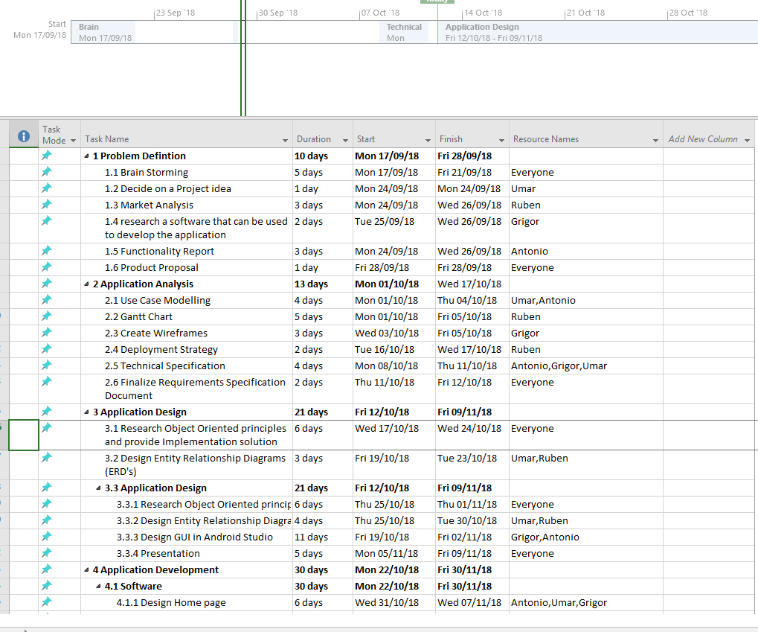

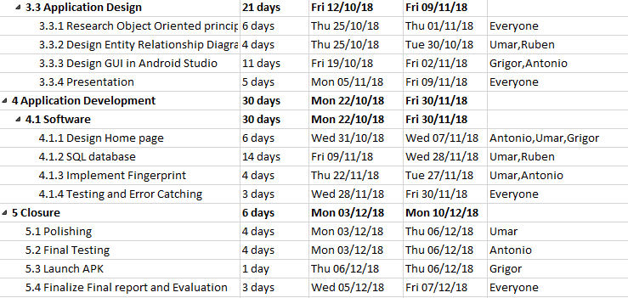

# Wireframes

**MAIN PAGE**

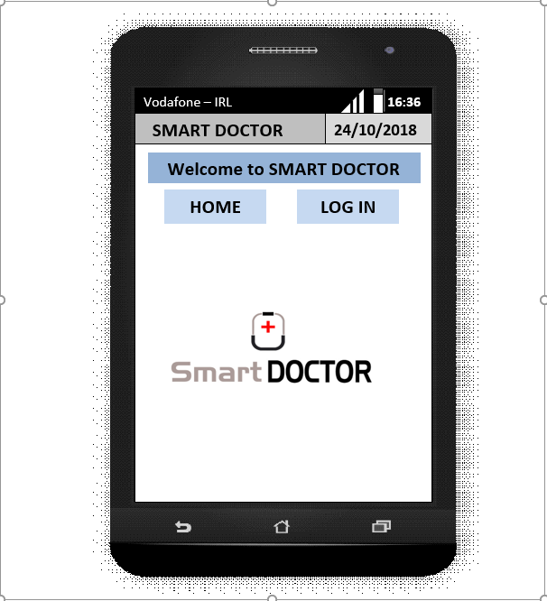

**LOG IN By:**

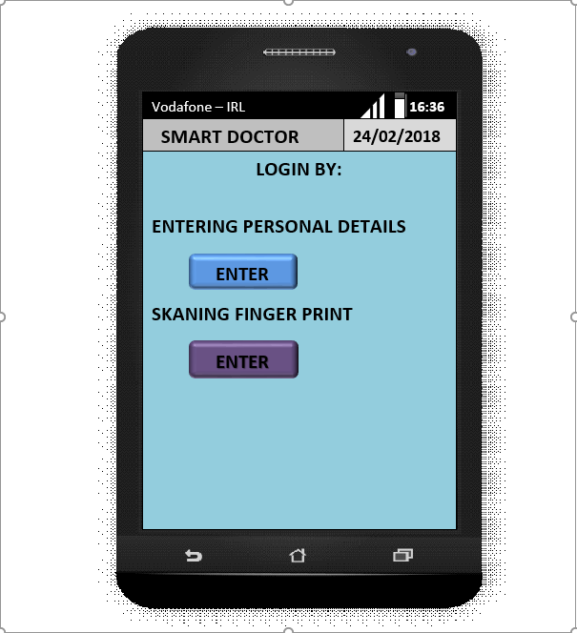

**LogIn Page**

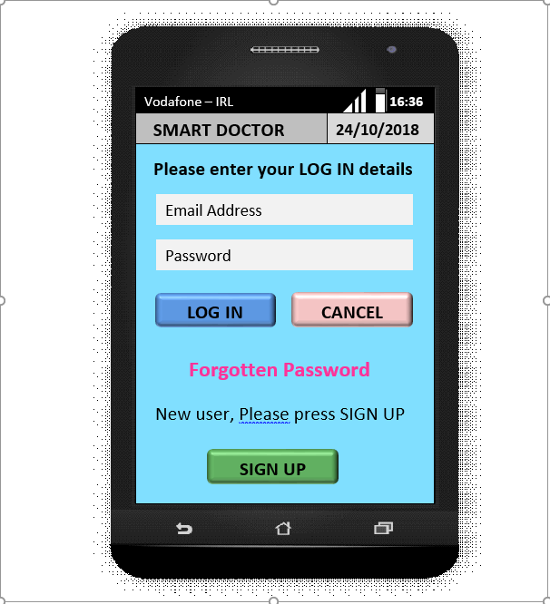

**REGISTER AS:**

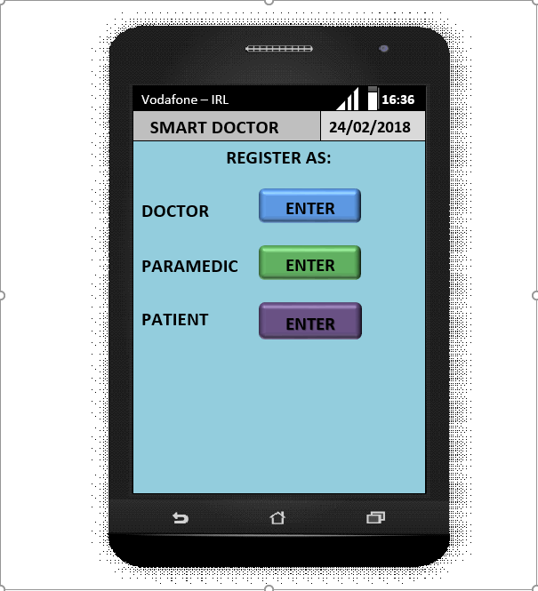

**REGISTER DOCTOR**

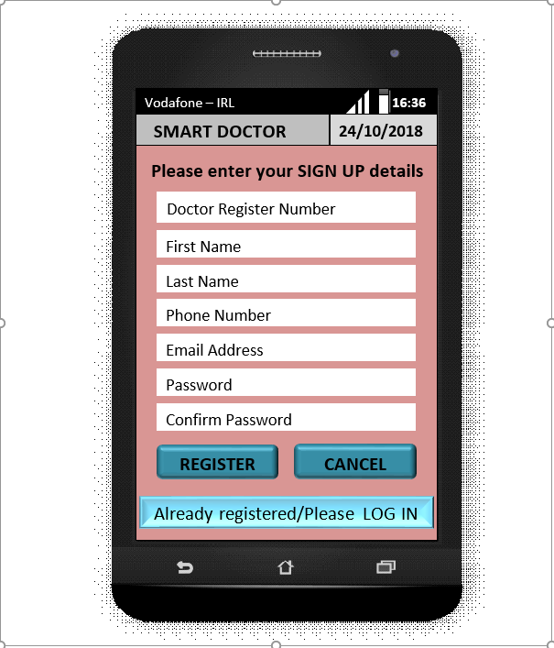

**REGISTER PATIENT**

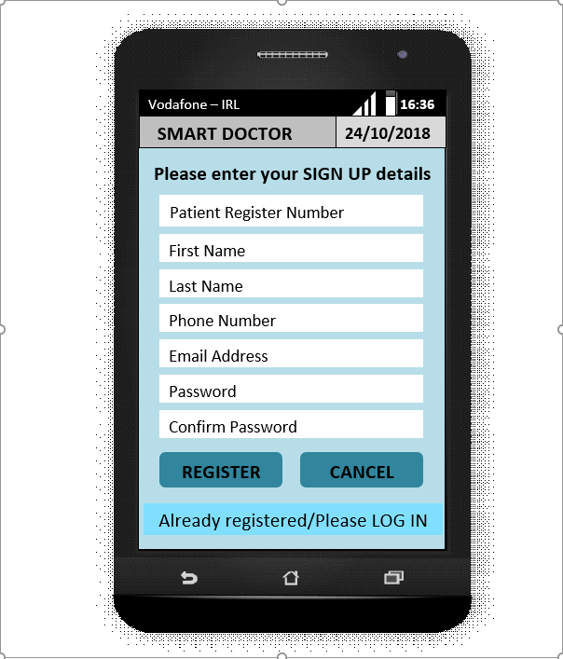

**PATIENT’S DETAILS**

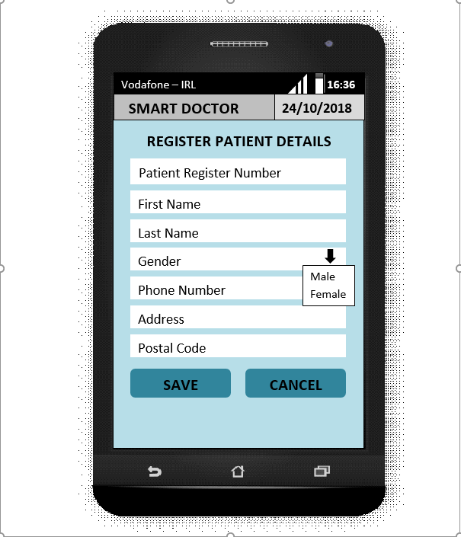

**IDENTIFY PATIENT**

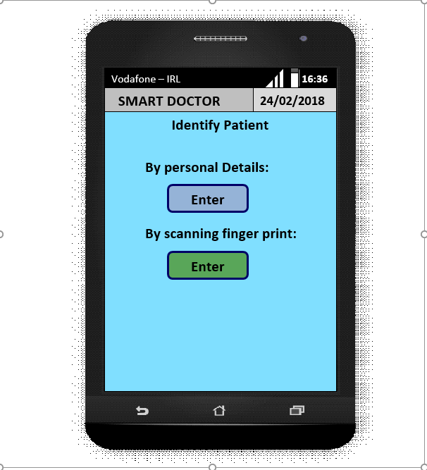

**SCAN FINGERPRINT**

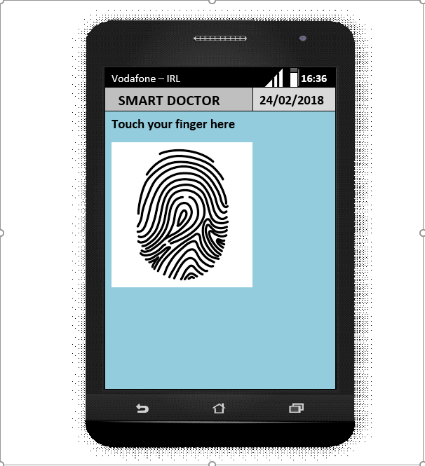

# Deployment Strategy

The final version of the application will be tested on many different android devices such as smartphones and tablets to see the how responsive is the application and the interoperability of the application. The applications deployment strategy will be 2 phases. The team will first deploy the application to a small group of people and hold testing of the product and fix anything that needs to be fixed before finally deploying in on the Google Play Store. The app will be available worldwide however only users in Ireland will be able to access their medical records as we will first test the app in Ireland for a period of 6 months before we deploy the technology worldwide and access databases of patients from other countries.

References

Android Developers. (2018). Android 6.0 APIs | Android Developers. [online] Available at: https://developer.android.com/about/versions/marshmallow/android-6.0 [Accessed 10 Oct. 2018].

Android Developers Blog. (2011). New Tools For Managing Screen Sizes. [online] Available at: https://android-developers.googleblog.com/2011/07/new-tools-for-managing-screen-sizes.html [Accessed 7 Oct. 2018].

Faulkner, C. (2015). What is NFC? Everything you need to know. [online] TechRadar. Available at: https://www.techradar.com/news/what-is-nfc [Accessed 8 Oct. 2018].

Official Android Blog. (2015). Get ready for the sweet taste of Android 6.0 Marshmallow. [online] Available at: https://android.googleblog.com/2015/10/get-ready-for-sweet-taste-of-android-60.html [Accessed 4 Oct. 2018].

ProAndroidDev. (2017). *Secure data in Android — Encryption in Android (Part 1)*. [online] Available at: https://proandroiddev.com/secure-data-in-android-encryption-in-android-part-1-e5fd150e316f [Accessed 9 Oct. 2018].

Statista. (2018). Mobile OS market share 2018 | Statista. [online] Available at: https://www.statista.com/statistics/266136/global-market-share-held-by-smartphone-operating-systems/ [Accessed 6 Oct. 2018].